

**TITLE:**

Technical Interview Preparation Portal

**BY**

18JG1A0583 SAHITHI SARIKA PONNADA

**GUIDE:** Satheesh

**ABSTRACT:**

The main objective of this project is to have a quick reference of all core subjects and general questions as well within a short period of time. It has admin, user login and signup pages. They are three streams computers or information technology, electronics and electrical and each of the stream has its respective companies. If student have any queries they can post them in the query page and check the answers in answer page. Admin can view student queries after logging in and respond to their queries by posting the answer.

**INTRODUCTION:**

Interview skills are an essential tool for all students in today’s world as there is increasing competition. The most important step to landing a job is being prepared for your interview. By doing some preparation you will feel more in control , and will appear cool , calm and collected . There are four basic steps you should take when preparing for an interview research yourself, practice, research the company and prepare logistically. It is important to organize a suite of compelling examples to convince the interviewer.

**REQUIREMENTS:**

Django

Django is a free and open-source web application framework, written in Python.

A web framework is a set of components that helps you to develop websites faster and easier.

Django is a collection of Python libs allowing you to quickly and efficiently create a quality Web application, and is suitable for both frontend and backend.

XAMPP

XAMPP is one of the widely used cross-platform web servers, which helps developers to create and test their programs on a local webserver.

XAMPP is an abbreviation for cross-platform, Apache, MySQL, **PHP** and Perl.

HTML

HTML stands for Hyper Text Markup Language.

HTML describes the structure of a Web page.

HTML is the standard markup language for creating Web pages.

HTML elements tell the browser how to display the content.

CSS

CSS stands for Cascading Style Sheets.

CSS describes how HTML elements are to be displayed on screen, paper, or in other media.

CSS saves a lot of work. It can control the layout of multiple web pages all at once.

External stylesheets are stored in CSS files.

BOOTSTRAP

Bootstrap 4 is the newest version of Bootstrap. It's open-source and free to use, yet features numerous HTML and CSS templates for UI interface elements such as buttons and forms.

Bootstrap is a potent front-end framework used to create modern websites and web apps.

**DESIGN:**

DATABASE TABLES

Tables Created

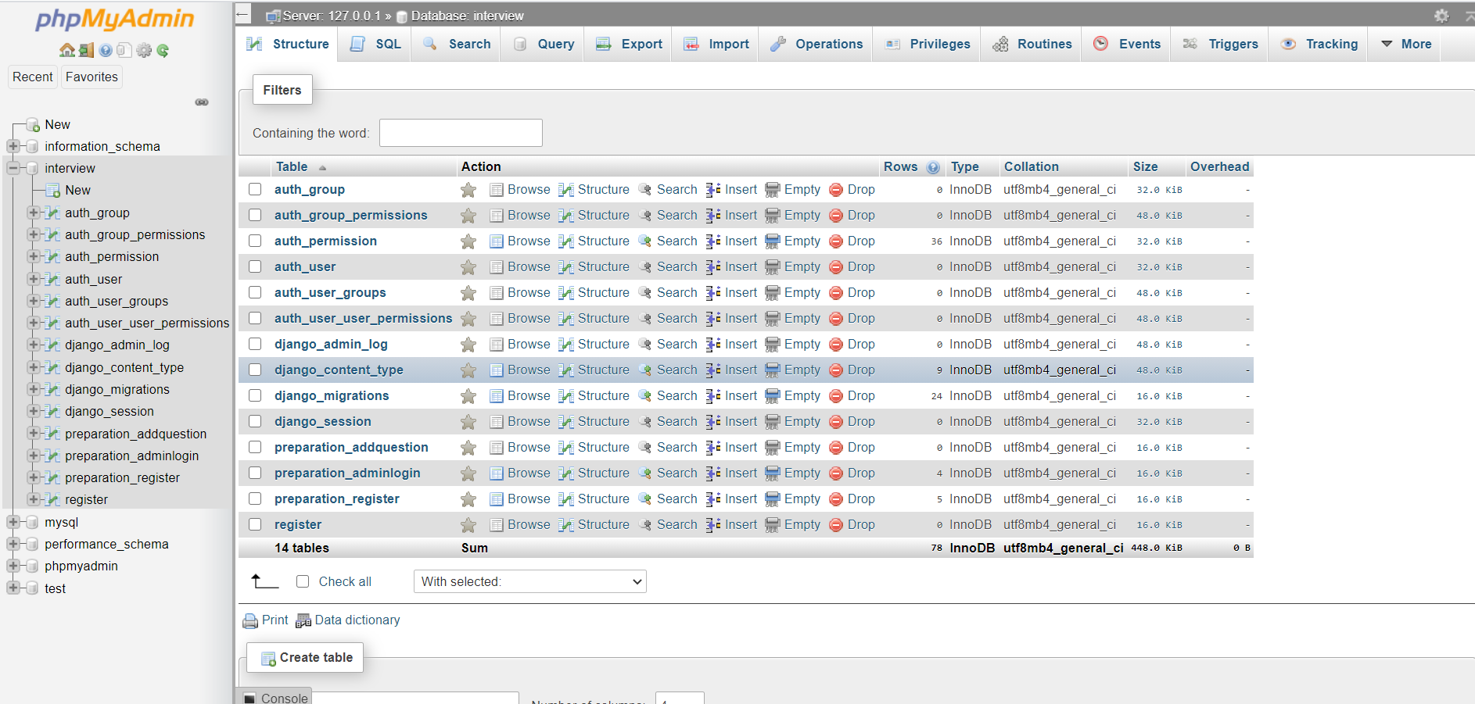

Signup Table

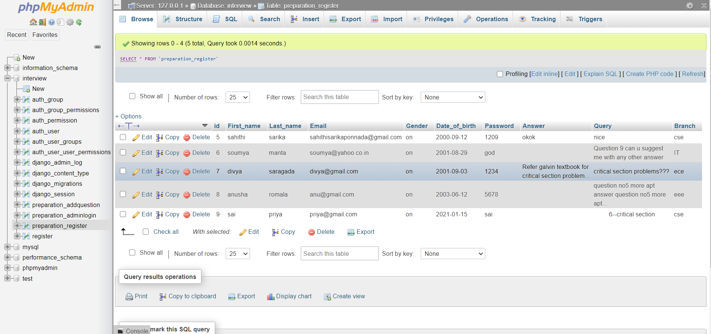

Admin Login Table

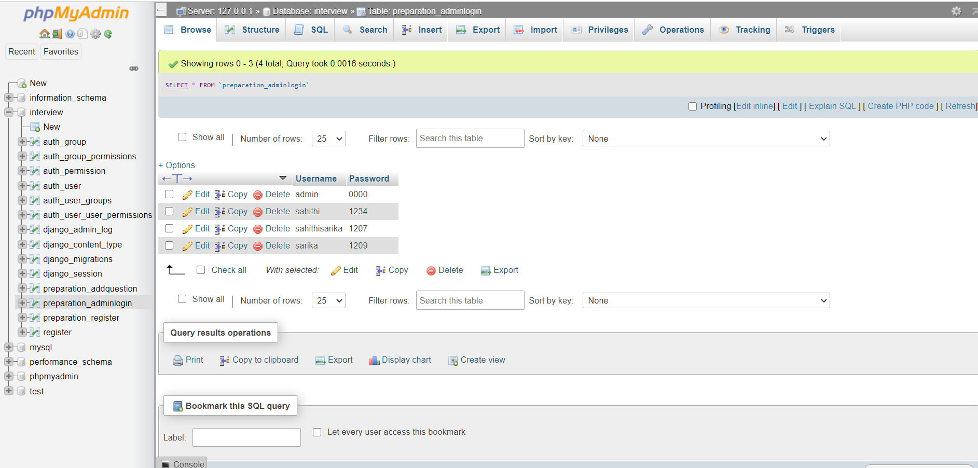

SCHEMA

Signup

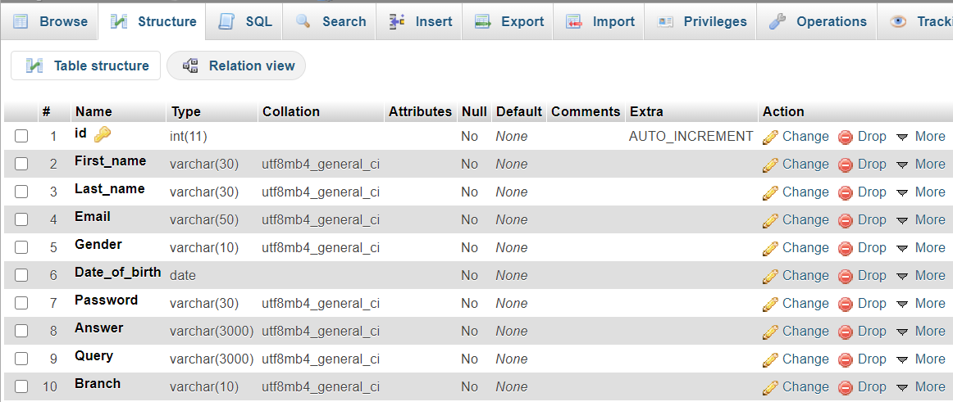

Admin Login

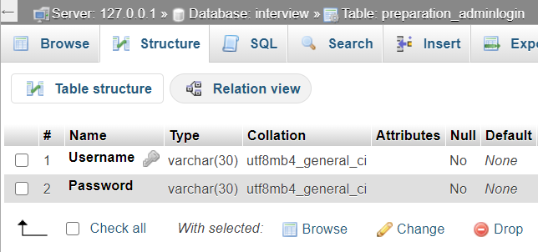

User Authentication

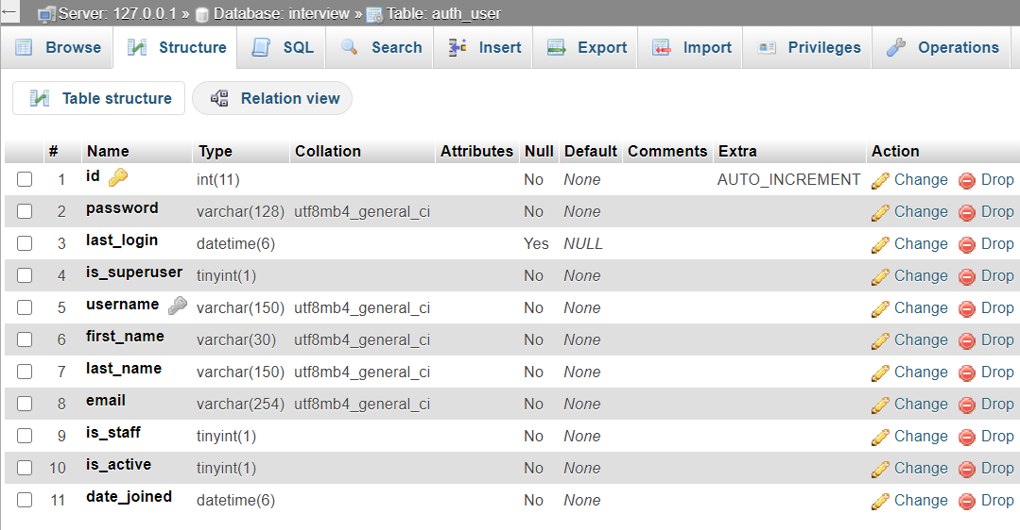

**CODE:**

Urls.py

from django.contrib import admin

from django.urls import path

from preparation import views

urlpatterns = [

path('admin/', admin.site.urls),

path('adminlogin/',views.adminlogin,name="adminlogin"),

path('userlogin/',views.userlogin,name="userlogin"),

path('home/',views.home,name="home"),

path('register/',views.register,name="register"),

path('about/',views.about,name="about"),

path('tcs/',views.tcs,name="tcs"),

path('wipro/',views.wipro,name="wipro"),

path('ibm/',views.ibm,name="ibm"),

path('wiproece/',views.wiproece,name="wiproece"),

path('intel/',views.intel,name="intel"),

path('lg/',views.lg,name="lg"),

path('wiproeceee/',views.wiproeee,name="wiproeee"),

path('reliance/',views.reliance,name="reliance"),

path('ongc/',views.ongc,name="ongc"),

path('questionnaire/',views.questionnaire,name="questionnaire"),

path('query/',views.query,name="query"),

path('admin/',views.admin,name="admin"),

path('addadmin/',views.addadmin,name="addadmin"),

path('viewstudentquery/',views.viewstudentquery,name="viewstudentquery"),

path('queryanswers.html/',views.queryanswers,name="queryanswers"),

path('answer.html/',views.answer,name="answer"),

path('email.html/',views.email,name="email"),

path('companycse.html/',views.companycse,name="companycse"),

path('companyece.html/',views.companyece,name="companyece"),

path('companyeee.html/',views.companyeee,name="companyeee"),

]

Models.py

from django.db import models

# Create your models here.

class Register(models.Model):

gender_val=[('male','male'),('female','female')]

First_name=models.CharField(max_length=30)

Last_name=models.CharField(max_length=30)

Email=models.EmailField(max_length=50)

Branch=models.CharField(max_length=10,default="")

Gender=models.CharField(max_length=10,choices=gender_val)

Date_of_birth=models.DateField(max_length=10)

Password=models.CharField(max_length=30)

Query=models.CharField(max_length=3000,default="")

Answer=models.CharField(max_length=3000,default="")

class Adminlogin(models.Model):

Username=models.CharField(max_length=30,primary_key=True)

Password=models.CharField(max_length=30)

Views.py

from django.contrib import messages

# Create your views here.

def home(req):

return render(req,"home.html")

def about(req):

return render(req,"about.html")

def adminlogin(req):

if req.method=='POST':

uname=req.POST['username']

pswd=req.POST['password']

try:

d=Adminlogin.objects.get(Username=uname,Password=pswd)

if d.Password==pswd:

return render(req,'admin.html')

else:

return HttpResponse("Invalid password")

except:

messages.warning(req,"username not found")

return render(req,'adminlogin.html')

def userlogin(req):

if req.method=='POST':

email=req.POST['email']

pswd=req.POST['password']

try:

data=Register.objects.get(Email=email)

if data.Password==pswd:

return redirect("questionnaire")

else:

return HttpResponse("Invalid password")

except:

return HttpResponse("username not found")

return render(req,"userlogin.html")

def register(req):

if req.method=='POST':

fnm=req.POST['First name']

lnm=req.POST['Last name']

email=req.POST['Email']

branch=req.POST['Branch']

gender=req.POST['Gender']

dob=req.POST['Dob']

pwd=req.POST['Pwd']

data=Register.objects.create(First_name=fnm,Last_name=lnm,Email=email,Branch=branch,Gender=gender,Date_of_birth=dob,Password=pwd)

data.save()

return redirect("questionnaire")

return render(req,'Signup.html')

def questionnaire(req):

return render(req,"sidenav.html")

def query(req):

if req.method=="POST":

branch=req.POST['Branch']

email=req.POST['TxtEmail']

query=req.POST['textmsg']

try:

data=Register.objects.get(Email=email,Branch=branch)

Register.objects.filter(Email=email,Branch=branch).update(Query=query+data.Query)

return HttpResponse("Your query successfully updated")

except:

return HttpResponse("Incorrect details")

return render(req,"query.html")

def admin(req):

return render(req,'admin.html')

def addadmin(req):

if req.method=='POST':

uname=req.POST['username']

pswd=req.POST['password']

try:

Adminlogin.objects.create(Username=uname, Password=pswd)

messages.success(req,"Data added successfully")

except:

messages.warning(req,"Incorrect data")

return render(req,'addadmin.html')

def viewstudentquery(req):

a=Register.objects.all()

return render(req,'viewstudentquery.html',{"o":a})

def queryanswers(req):

if req.method=='POST':

branch=req.POST['Branch']

mail=req.POST['Mail']

answer=req.POST['Text']

a=Register.objects.get(Email=mail,Branch=branch)

Register.objects.filter(Email=mail,Branch=branch).update(Answer=answer+a.Answer)

return HttpResponse("Answered successfully")

return render(req,'queryanswers.html')

def email(req):

if req.method=="POST":

email=req.POST['Email']

try:

data=Register.objects.get(Email=email)

if data is not None:

return render(req,'answer.html',{"d":data})

except:

return render(req,"email.html")

return render(req,'answer.html')

def answer(req):

return render(req,'email.html')

def companycse(req):

return render(req,'companycse.html')

def companyece(req):

return render(req,'companyece.html')

def companyeee(req):

return render(req,'companyeee.html')

def tcs(req):

return render(req,'tcs.html')

def wipro(req):

return render(req,'wipro.html')

def ibm(req):

return render(req,'ibm.html')

def wiproece(req):

return render(req,'wiproece.html')

def intel(req):

return render(req,'intel.html')

def lg(req):

return render(req,'lg.html')

def wiproeee(req):

return render(req,'wiproeee.html')

def reliance(req):

return render(req,'reliance.html’)

def ongc(req):

return render(req,'ongc.html')

TEMPLATES

## **ADD ADMIN**

{% extends 'navbar.html' %}

{% block body %}

<!DOCTYPE html>

<html>

<head>

<title></title>

</head>

<body>

<body style="color :black">

<div class="container">

<div class='card'>

<div class='card-header'>

<h3 color="black">Add admin</h3>

</div>

<div class='card-body'>

<form action="{% url 'addadmin' %}" method='POST'>

{% csrf_token %}

{% if messages %}

{% for msg in messages %}

<div class='alert alert-{{msg.tags}}'>{{msg}}</div>

{% endfor %}

{% endif %}

<p><label>User Name:&nbsp</label><input type="text" name="username"></p>

<p><label>Password:&nbsp &nbsp </label><input type="text" name="password"></p>

<div class='card-footer'>

<input class='btn btn-success' type='submit' value='login'>

</div>

</form>

</div>

</div>

</div>

</body>

</html>

{% endblock %}

## **ADMIN**

<!DOCTYPE html>

<html>

<head>

<title></title>

<style type="text/css">

.a{

border: none;

background-color: black;

color: white;

padding: 16px 32px;

text-align: center;

text-decoration: none;

display: inline-block;

font-size: 16px;

margin: 4px 2px;

margin-top: 70px;

transition-duration: 0.4s;

cursor: pointer;

}

</style>

</head>

<body>

<h2 align="center"><a href="{% url 'addadmin' %}"><button class="a">Add admin</button></a></h2>

<h2 align="center"><a href="{% url 'viewstudentquery' %}"><button class="a">View student queries</button></a></h2>

</body>

</html>

## **ADMIN LOGIN**

{% extends 'navbar.html' %}

{% block body %}

<!DOCTYPE html>

<html>

<head>

<title color="black">Admin</title>

</head>

<body style="color :black">

<div class="container">

<div class='card'>

<div class='card-header'><h3 color="black">Admin</h3></div>

<div class='card-body'>

<form action="{% url 'adminlogin' %}" method='POST'>

{% csrf_token %}

{% if messages %}

{% for msg in messages %}

<div class='alert alert-{{msg.tags}}'>{{msg}}</div>

{% endfor %}

{% endif %}

<p><label>User Name:&nbsp;</label><input type="text" name="username"></p>

<p><label>Password: &nbsp; &nbsp; </label><input type="password" name="password"></p>

<div class='card-footer'>

<input class='btn btn-success' type='submit' value='login'>

</div>

</form>

</div>

</div>

</div>

</body>

</html>

{% endblock %}

## **ANSWER**

<!DOCTYPE html>

<html>

<head>

<title></title>

<meta charset="utf-8">

<meta name="viewport" content="width=device-width, initial-scale=1">

<link rel="stylesheet" href="https://maxcdn.bootstrapcdn.com/bootstrap/4.5.0/css/bootstrap.min.css">

<script src="https://ajax.googleapis.com/ajax/libs/jquery/3.5.1/jquery.min.js"></script>

<script src="https://cdnjs.cloudflare.com/ajax/libs/popper.js/1.16.0/umd/popper.min.js"></script>

<script src="https://maxcdn.bootstrapcdn.com/bootstrap/4.5.0/js/bootstrap.min.js"></script>

<style type="text/css">

table, th, td {

border: 1px solid black;

border-collapse: collapse;

margin: center;

}

</style>

</head>

<body>

<div class="container">

{% if messages %}

{% for msg in messages %}

<h4 class="alert-success">{{msg}}</h4>

{% endfor %}

{% endif %}

<div class="row">

<div class="col-sm-1"></div>

<div class="col-sm-9"></div>

<div class="table">

<table style="width:100%">

<tr>

<th>Queries</th>

<th>Answer</th>

</tr>

<tr>

<td>{{d.Query}}</td>

<td>{{d.Answer}}</td>

</tr>

</table>

</div>

<div class="col-sm-1"></div>

</div>

</div>

</body>

</html>

## **COMPANYCSE**

<!DOCTYPE html>

<html>

<head>

<title></title>

<style type="text/css">

.a{

border: none;

margin-top: 5%;

color: white;

padding: 16px 32px;

text-align: center;

text-decoration: none;

display: inline-block;

font-size: 16px;

transition-duration: 0.4s;

cursor: pointer;

}

</style>

</head>

<body>

<h2 align="center"><a href="{% url 'tcs' %}"><button class="a" style="background-color: darkblue">TCS</button></a></h2>

<h2 align="center"><a href="{% url 'wipro' %}"><button class="a" style="background-color: orchid">WIPRO</button></a></h2>

<h2 align="center"><a href="{% url 'ibm' %}"><button class="a" style="background-color: black">IBM</button></a></h2>

</body>

</html>

## **COMPANYECE**

<!DOCTYPE html>

<html>

<head>

<title></title>

<style type="text/css">

.a{

border: none;

margin-top: 5%;

color: white;

padding: 16px 32px;

text-align: center;

text-decoration: none;

display: inline-block;

font-size: 16px;

transition-duration: 0.4s;

cursor: pointer;

}

</style>

</head>

<body>

<h2 align="center"><a href="{% url 'intel' %}"><button class="a" style="background-color: darkblue">INTEL(Analog & Digital Electronics)</button></a></h2>

<h2 align="center"><a href="{% url 'wiproece' %}"><button class="a" style="background-color: orchid">WIPRO(wireless networking)</button></a></h2>

<h2 align="center"><a href="{% url 'lg' %}"><button class="a" style="background-color:#CD5C5C">LG ELECTRONICS(Analog & Digital Electronics)</button></a></h2>

</body>

</html>

## **COMPANYEEE**

<!DOCTYPE html>

<html>

<head>

<title></title>

<style type="text/css">

.a{

border: none;

margin-top: 5%;

color: white;

padding: 16px 32px;

text-align: center;

text-decoration: none;

display: inline-block;

font-size: 16px;

transition-duration: 0.4s;

cursor: pointer;

}

</style>

</head>

<body>

<h2 align="center"><a href="{% url 'reliance' %}"><button class="a" style="background-color:#348017">RELIANCE</button></a></h2>

<h2 align="center"><a href="{% url 'wiproece' %}"><button class="a" style="background-color: orchid">WIPRO</button></a></h2>

<h2 align="center"><a href="{% url 'ongc' %}"><button class="a" style="background-color:maroon">ONGC</button></a></h2>

</body>

</html>

## **EMAIL**

<!DOCTYPE html>

<html>

<head>

<title></title>

<style type="text/css">

.a{

border: none;

background-color: green;

color: white;

padding: 16px 32px;

text-align: center;

text-decoration: none;

display: inline-block;

font-size: 16px;

margin: 4px 2px;

margin-top: 70px;

transition-duration: 0.4s;

cursor: pointer;

}

.p{

}

</style>

</head>

<body>

<form action="{% url 'email' %}" method="POST">

{% csrf_token %}

<p align="center"><label >Email:&nbsp;</label><input type="text" name="Email" style="width: 20%; margin-top: 5%;"></p>

<h2 align="center" style="margin-bottom:5%"><a href="#"><button class="a">Submit</button></a></h2>

</form>

</body>

</html>

## **HOME**

{% extends 'navbar.html' %}

{% load static %}

{% block body %}

<!DOCTYPE html>

<html>

<head>

<title>Home</title>

<style type="text/css">

.h1{

font-family: sans-serif;

font-style: oblique;

}

.center {

display: block;

margin-top: 50px;

margin-bottom: 30px;

margin-left: 38%;

margin-right: 10%;

width: 20%;

}

</style>

</head>

<body>

<h1 align="center">

<img src="https://images.app.goo.gl/GmWFfzDkwXTdj6kV9">

<h1 align="center" style="color: black;">INTERVIEW PREPARATION PORTAL</h1>

<img src="https://searchlight.vc/searchlight/wp-content/uploads/sites/2/2019/08/job-interview-750x500.jpg" class="center" align="center" style="height: 13%;width:23%;padding-left: 3%;">

</body>

</html>

{% endblock %}

**NAVBAR**

<!DOCTYPE html>

<html>

<head>

<title>Navbar</title>

<meta charset="utf-8">

<meta name="viewport" content="width=device-width, initial-scale=1">

<link rel="stylesheet" href="https://maxcdn.bootstrapcdn.com/bootstrap/4.5.0/css/bootstrap.min.css">

<script src="https://ajax.googleapis.com/ajax/libs/jquery/3.5.1/jquery.min.js"></script>

<script src="https://cdnjs.cloudflare.com/ajax/libs/popper.js/1.16.0/umd/popper.min.js"></script>

<script src="https://maxcdn.bootstrapcdn.com/bootstrap/4.5.0/js/bootstrap.min.js"></script>

</head>

<body>

<nav class="navbar navbar-expand-sm bg-dark navbar-dark">

<ul class="navbar-nav nav-tabs ml-auto">

<li>

<a class="nav-link" href="{% url 'home' %}"><b>Home</b> &nbsp;</a>

</li>

<li>

<a class="nav-link" href="{% url 'adminlogin' %}"><b>Admin</b>&nbsp;</a>

</li>

<li class="nav-item">

<a class="nav-link" href="{% url 'userlogin' %}"><b>Userlogin</b> &nbsp;</a>

</li>

<li class="nav-item">

<a class="nav-link" href="{% url 'register' %}"><b>Signup</b> &nbsp;</a>

</li>

</ul>

</nav>

{% block body %}

{% endblock %}

</body>

</html>

## **ONGC**

<!DOCTYPE html>

<html>

<head>

<title></title>

<style type="text/css">

.h2{

color: #008CBA

}

.a{

border: none;

background-color: #008CBA;

color: white;

padding: 16px 32px;

text-align: center;

text-decoration: none;

display: inline-block;

font-size: 16px;

margin: 4px 2px;

transition-duration: 0.4s;

cursor: pointer;

}

body{

padding-left:20%;

padding-right: 10px;

}

</style>

</head>

<body>

<ol>

<li><p><h3 style="font-size:20px">Why do you want to be selected at ONGC?</h3></p></li>

<a href="https://www.quora.com/Why-do-you-wish-to-join-ONGC" target="_blank" style="font-size:20px">Answer:quora.com</a>

<li><p><h3 style="font-size:20px">During the operation of the transformer, what are parameters we need to check?</h3></p></li>

<a href="https://www.dfliq.net/blog/maintenance-tips-electrical-transformers/#:~:text=Your%20electrical%20transformer%20needs%20to,it%20is%20to%20transformer%20oil." target="_blank" style="font-size:20px">Answer:dfliq.net</a>

<li><p><h3 style="font-size:20px">What is the duration to measure oil temperature in the transformer?</h3></p></li>

<a href="https://www.electrical4u.com/transformer-oil-and-winding-temperature-rise-test/#:~:text=There%20is%20another%20method%20of,temperature%20rise%20of%20the%20oil." target="_blank" style="font-size:20px">Answer:electrical4u.com</a>

<li><p><h3 style="font-size:20px">What is the dielectric?</h3></p></li>

<a href="https://www.britannica.com/science/dielectric" target="_blank" style="font-size:20px">Answer:britannica.com</a>

<li><p><h3 style="font-size:20px">Tell me about yourself?</h3></p></li>

<a href="themuse.com/advice/tell-me-about-yourself-interview-question-answer-examples" target="_blank" style="font-size:20px">Answer:themuse.com</a>

<li><p><h3 style="font-size:20px">why transformer donot allow the dc?</h3></p></li>

<a href="https://energyeducation.ca/encyclopedia/Transformer#:~:text=As%20mentioned%20before%2C%20transformers%20do,DC%20input%20to%20flow%20through.&text=This%20is%20because%20a%20change,voltage%20across%20the%20secondary%20component." target="_blank" style="font-size:20px">Answer:energyeducation.ca</a>

<li><p><h3 style="font-size:20px">formula for cable size calculation for current?</h3></p></li>

<a href="https://electrical-engineering-portal.com/an-example-how-to-calculate-voltage-drop-and-size-of-electrical-cable" target="_blank" style="font-size:20px">Answer:electrical-engineering-portal.com</a>

<li><p><h3 style="font-size:20px">how many types of colling system it transformers?</h3></p></li>

<a href="https://testguy.net/content/184-Transformer-Cooling-Systems-and-Methods#:~:text=ONAN%2FONAF%2FOFAF%20(OA%2FFA%2FFOA)&text=The%20transformer%20has%20self%2Dcooling,corresponding%20to%20each%20cooling%20step." target="_blank" style="font-size:20px">Answer:testguy.net</a>

<li><p><h3 style="font-size:20px">Where Is The Company Headquarter?</h3></p></li>

<a href="https://www.wisdomjobs.com/e-university/ongc-interview-questions.html" target="_blank" style="font-size:20px">Answer:wisdomjobs.com</a>

<li><p><h3 style="font-size:20px">When This Company Was Established?</h3></p></li>

<a href="https://www.wisdomjobs.com/e-university/ongc-interview-questions.html" target="_blank" style="font-size:20px">Answer:wisdomjobs.com</a>

<h2 align="center" style="margin-right:20%"><a href="{% url 'query' %}"><button class="a">click here to post the query</button></a></h2>

</ol>

</body>

</html>

## **QUERY**

{%load static%}

<!DOCTYPE html>

<html>

<head>

<meta charset="utf-8">

<meta name="viewport" content="width=device-width, initial-scale=1.0">

<title></title>

<link rel="stylesheet" href="https://maxcdn.bootstrapcdn.com/bootstrap/3.4.1/css/bootstrap.min.css">

<script src="https://cdnjs.cloudflare.com/ajax/libs/popper.js/1.12.9/umd/popper.min.js"> </script>

<script src="https://ajax.googleapis.com/ajax/libs/jquery/3.5.1/jquery.min.js"></script>

<script src="https://maxcdn.bootstrapcdn.com/bootstrap/3.4.1/js/bootstrap.min.js"></script>

<style type="text/css">

body

{

background :#D3D3D3;

}

.feedback-form{

background: white;

padding : 5px 60px;

margin-top: 1%;

margin-bottom: 1%;

}

.feedback-form .form-control{

border-radius: 1rem;

width:550px;

height: 150px;

margin-bottom: 8px;

}

.feedback-image{

text-align: center;

}

.feedback-image .img{

border-radius: 7rem;

width: 11%;

margin-top: -3%;

transform: rotate(29deg);

}

.feedback-form form{

padding: 10%;

}

.feedback-form form .row{

margin-bottom: -7%;

}

.feedback-form h3{

margin-bottom: 6%;

margin-top:-10%;

text-align: center;

color: black;

}

.feedback-form .btn btn-success{

width: 50%;

border: none;

border-radius: 1rem;

padding: 1.5%;

background: #c0c0c0;

font-width:600;

color: #fff;

cursor: pointer;

}

.feedback-form p{

margin-top: 10px;

margin-bottom: 3px;

color: grey;

}

</style>

</head>

<body>

<div class="container feedback-form">

<div class="feedback-image">

<img src="https://encrypted-tbn0.gstatic.com/images?q=tbn:ANd9GcQXu6VaIuJ-2M5WZasditaDpekrZhCrxiwIpw&usqp=CAU">

</div>

<form method="POST" action="{% url 'query' %}">

{% csrf_token %}

<h3><b>Drop Us Your Queries</b></h3>

<div class="row">

<div class="col-md-6">

<div class="form-group">

<label><h4>Branch&nbsp;<input type="text" class="from-control" placeholder="Your Branch" name="Branch"></h4></label>

</div>

<div class="form-group">

<label><h4>Email &nbsp;<input type="text" class="from-control" placeholder="Your Email" name="TxtEmail"></h4></label>

</div><br>

<label><h4><b>Any queries please let us know along with the question number</b></h4>

<textarea name="textmsg" class="from-control" rows="7" cols="70">

</textarea></label><br><br>

<div class="form-group">

<input type="submit" name="btnsubmit" class="btn btn-success" value="submit the query" style="outline: none;">

</div>

</div>

</div>

</form>

</div>

</body>

</html>

## **QUERYANSWERS**

<!DOCTYPE html>

<html>

<head>

<title></title>

<meta name="viewport" content="width=device-width, initial-scale=1.0">

<link rel="stylesheet" href="https://maxcdn.bootstrapcdn.com/bootstrap/3.4.1/css/bootstrap.min.css">

<script src="https://cdnjs.cloudflare.com/ajax/libs/popper.js/1.12.9/umd/popper.min.js"> </script>

<script src="https://ajax.googleapis.com/ajax/libs/jquery/3.5.1/jquery.min.js"></script>

<script src="https://maxcdn.bootstrapcdn.com/bootstrap/3.4.1/js/bootstrap.min.js"></script>

<style type="text/css">

.Answer-form{

background: white;

padding : 2px 2px;

margin-top: 5%;

margin-bottom: 1%;

}

.Answer-form .form-control{

border-radius:1rem;

}

.Answer-form form{

padding: 14%;

}

.Answer-form .btn btn-success{

width: 50%;

border: none;

border-radius: 1rem;

padding: 1.5%;

background: #c0c0c0;

font-width:600;

color: #fff;

cursor: pointer;

}

</style>

</head>

<body>

<div class="container Answer-form">

<form action="{% url 'queryanswers' %}" method="POST">

{% csrf_token %}

<div class="row">

<div class="col-md-6">

<div class="form-group">

<input type="text" class="from-control" placeholder="Your Branch" name="Branch" style="width: 150px;height: 50px">

</div>

<div class="form-group">

<input type="text" name="Mail" placeholder="Email" style="width: 300px;height: 50px"><br>

</div>

<div class="form-group">

<label><h3><b>Answer the query :</b></h3></label>

<textarea name="textmsg" class="from-control" style="width:450px;height: 150px;margin-bottom: 8px" rows="7" cols="70">

</textarea><br>

</div>

<div class="form-group">

<input class="btn btn-success" type="submit" value="submit">

</div>

</div>

</div>

</form>

</body>

</html>

## **SIDENAV**

<!DOCTYPE html>

<html>

<head>

<meta name="viewport" content="width=device-width, initial-scale=1">

<style type="text/css">

body

{

font-family: 'Roboto' , sans-serif;

}

*{

margin: 0;

padding: 0;

list-style: none;;

text-decoration: none;

}

.h1{

margin-top: 100px;

}

.center {

display: block;

margin-top: 100px;

margin-bottom: 100px;

margin-left: 450px;

margin-right: 550px;

width: 40%;

}

.sidebar{

position: fixed;

left: -250px;

width: 200px;

height: 100%;

background: #042331;

transition: all 0.5s ease;

}

.sidebar header{

color: white;

text-align: center;

line-height: 50px;

background: #063146;

user-select: none;

}

.sidebar ul a{

display: block;

height: 100%;

width: 100%;

line-height: 70px;

font-size: 16px;

color: white;

padding-left: 40px;

box-sizing: border-box;

border-top: 1px solid rgba(255,255,255,.1);

border-bottom: 1px solid black;

background: #042331;

}

ul li:hover a{

padding-left: 50px;

}

#check

{

display: none;

}

label #btn,label #cancel

{

position: all;

cursor:pointer;

background: #042331;

border-radius: 5px;

}

label #btn

{

position:absolute;

left: 5px;

top: 5px;

font-size: 15px;

color: white;

padding: 4px 10px;

transition: all 0.5s;

}

label #cancel

{

z-index: 1111;

left:-195px;

top: 12px;

font-size: 20px;

color: grey;

padding: 4px 9px;

transition: all 0.5s ease;

}

#check:checked ~ .sidebar{

left: 0;

}

#check:checked ~ .label #btn{

left: 250px;

opacity: 0;

pointer-events: none;

}

#check:checked ~ .label #cancel{

left: 195px;

}

#check:checked ~ section{

margin-left: 250px;

}

body{

background-image: url("https://images.unsplash.com/photo-1563518839049-f44a5e423f12?ixid=MXwxMjA3fDB8MHxwaG90by1wYWdlfHx8fGVufDB8fHw%3D&ixlib=rb-1.2.1&auto=format&fit=crop&w=1950&q=80");

background-repeat:no-repeat;

background-position:center;

background-size: 100% 150%;

height: 100vh;

transition: all 0.5s;

}

</style>

<title>Side Menu Bar</title>

<script src="https://kit.fontawesome.com/a076d05399.js" type="text/javascript"></script>

</head>

<body>

<input type="checkbox" id="check">

<label for="check">

<i class="fas fa-bars" id="btn"></i>

</label>

<div class="sidebar">

<header> &nbsp; &nbsp; &nbsp; &nbsp; &nbsp; &nbsp; &nbsp; &nbsp; &nbsp; &nbsp; &nbsp; &nbsp; &nbsp; &nbsp; &nbsp; &nbsp; &nbsp; &nbsp;

<label for="check">

<i class="fas fa-times" id="cancel"></i>

</label>

</header>

<ul>

<li>

<a href="{% url 'about' %}">ABOUT</a>

</li>

<li>

<a href="{% url 'companycse' %}">CSE/IT</a>

</li>

<li>

<a href="{% url 'companyece' %}">ECE</a>

</li>

<li>

<a href="{% url 'companyeee' %}">EEE</a>

</li>

<li>

<a href="{% url 'query' %}">QUERIES</a>

</li>

<li>

<a href="{% url 'answer' %}">ANSWER</a>

</li>

</ul>

</div>

<h1 align="center" style="color:white;" >HELP YOU PREPARE FOR JOB INTERVIEWS</h1>

<img src="https://www.foxtekrs.com/rails/active_storage/blobs/eyJfcmFpbHMiOnsibWVzc2FnZSI6IkJBaHBBNERhQnc9PSIsImV4cCI6bnVsbCwicHVyIjoiYmxvYl9pZCJ9fQ==--9cadd3fd6bed2a320b6139b192ccf68f4a8d8336/Interview%20Prep%20Image.jpg" class="center">

{% block body %}

{% endblock %}

</body>

</html>

## **SIGNUP**

{% extends 'navbar.html' %}

{% block body %}

<!DOCTYPE html>

<html lang="en">

<head>

<title>Sign up for students</title>

<style type="text/css">

#share-buttons img {

width: 35px;

padding: 5px;

border: 0;

box-shadow: 0;

display: inline;

}

</style>

</head>

<div class="container">

<div class='card'>

<div class='card-header'><h4>Sign up</h4></div>

<div class='card-body' align="center">

<body style="background-color:grey">

<form action="{% url 'register' %}" method="POST">

{% csrf_token %}

<input type="text" name="First name" placeholder="First name"><br><br>

<input type="text" name="Last name" placeholder="Last name"><br><br>

<input type="text" name="Email" placeholder="Email"><br><br>

<input type="text" name="Branch" placeholder="Branch"><br><br>

<input type="radio" name="Gender">Male <input type="radio" name="Gender">Female<br><br>

<input type="date" name="Dob" placeholder="Dob"><br><br>

<input type="password" name="Pwd" placeholder="Enter Password" name="Pwd"><br><br>

<div class='card-footer'>

<input class='btn btn-success' type='submit' value='Create an account'>

</div><br><br>

<div class="right-box">

<p><h3>---------or share with---------<h3></p>

</div>

<!-- Email -->

<a href="mailto:?Subject=Simple Share Buttons&amp;Body=I%20saw%20this%20and%20thought%20of%20you!%20 https://simplesharebuttons.com">

<img src="https://simplesharebuttons.com/images/somacro/email.png" alt="Email" />

</a>

<!-- Facebook -->

<a href="http://www.facebook.com/sharer.php?u=https://simplesharebuttons.com" target="_blank">

<img src="https://simplesharebuttons.com/images/somacro/facebook.png" alt="Facebook" />

</a>

<!-- LinkedIn -->

<a href="http://www.linkedin.com/shareArticle?mini=true&amp;url=https://simplesharebuttons.com" target="_blank">

<img src="https://simplesharebuttons.com/images/somacro/linkedin.png" alt="LinkedIn" />

</a>

<!-- Twitter -->

<a href="https://twitter.com/share?url=https://simplesharebuttons.com&amp;text=Simple%20Share%20Buttons&amp;hashtags=simplesharebuttons" target="_blank">

<img src="https://simplesharebuttons.com/images/somacro/twitter.png" alt="Twitter" />

</a>

</div>

</div>

</div>

</form>

</body>

</html>

{% endblock %}

## **TCS**

<!DOCTYPE html>

<html>

<head>

<title></title>

<style type="text/css">

.h2{

color: #008CBA

}

.a{

border: none;

background-color: #008CBA;

color: white;

padding: 16px 32px;

text-align: center;

text-decoration: none;

display: inline-block;

font-size: 16px;

margin: 4px 2px;

transition-duration: 0.4s;

cursor: pointer;

}

body{

padding-left:20%;

padding-right: 10px;

}

</style>

</head>

<body>

<ol>

<li><p><h3 style="font-size:20px">What is data abstraction? what are the three levels of data abstraction with Example?</h3></p></li>

<a href="https://www.conduiraonline.com/index.php/detail/1955-" target="_blank" style="font-size:20px">Answer:conduiraonline.com</a>

<li><p><h3 style="font-size:20px">What is a command-line argument?</h3></p></li>

<a href="https://www.conduiraonline.com/index.php/detail/1955-" target="_blank" style="font-size:20px">Answer:conduiraonline.com</a>

<li><p><h3 style="font-size:20px">Advantages of a macro over a function?</h3></p></li>

<a href="https://www.conduiraonline.com/index.php/detail/1955-" target="_blank" style="font-size:20px">Answer:conduiraonline.com</a>

<li><p><h3 style="font-size:20px"> Which header file should you include if you are to develop a function which can accept a variable number of arguments?</h3></p></li>

<a href="https://www.conduiraonline.com/index.php/detail/1955-" target="_blank" style="font-size:20px">Answer:conduiraonline.com</a>

<li><p><h3 style="font-size:20px">What is the Difference Between Hard Work and Smart Work?</h3></p></li>

<a href="https://prepinsta.com/tcs-nqt/placement-papers/interview-questions/hr-round/what-is-the-difference-between-hard-work-and-smart-work/" target="_blank" style="font-size:20px">Answer:prepinsta.com</a>

<li><p><h3 style="font-size:20px">Why TCS and CEO OF TCS?</h3></p></li>

<a href="https://prepinsta.com/tcs-nqt/placement-papers/interview-questions/hr-round/why-tcs/" target="_blank" style="font-size:20px">Answer:prepinsta.com</a>

<li><p><h3 style="font-size:20px">If you get a job with a higher package from here, what will you do?</h3></p></li>

<a href="https://prepinsta.com/tcs-nqt/placement-papers/interview-questions/hr-round/if-you-get-a-job-with-a-higher-package-from-here-what-will-you-do/" target="_blank" style="font-size:20px">Answer:prepinsta.com</a>

<li><p><h3 style="font-size:20px">Why should I hire you within 200 students?</h3></p></li>

<a href="https://prepinsta.com/tcs-nqt/placement-papers/interview-questions/managerial-round/why-should-i-hire-you-within-200-students/" target="_blank" style="font-size:20px">Answer:prepinsta.com</a>

<li><p><h3 style="font-size:20px">How will you manage a team of trainees ?</h3></p></li>

<a href="https://prepinsta.com/tcs-nqt/placement-papers/interview-questions/managerial-round/how-will-you-manage-a-team-of-trainees/" target="_blank" style="font-size:20px">Answer:prepinsta.com</a>

<li><p><h3 style="font-size:20px">Suppose you are traveling in a boat with your wife and father, and the boat started drowning, whom will you save? </h3></p></li>

<a href="https://prepinsta.com/tcs-nqt/placement-papers/interview-questions/managerial-round/who-will-you-save-your-wife-or-father-from-a-drowning-boat/" target="_blank" style="font-size:20px">Answer:prepinsta.com</a>

<h2 align="center" style="margin-right:20%"><a href="{% url 'query' %}"><button class="a">click here to post the query</button></a></h2>

</ol>

</body>

</html>

## **USERLOGIN**

{% extends 'navbar.html' %}

{% block body %}

<!DOCTYPE html>

<html>

<head>

<title>Login Form</title>

<style type="text/css">

h6

{

text-align: right;

}

</style>

</head>

<body>

<div class="container">

<div class='card'>

<div class='card-header'>Login Form</div>

<div class='card-body'>

<form class="box" action="{% url 'userlogin' %}" method="POST">

{% csrf_token %}

{% if messages %}

{% for msg in messages %}

<div class='alert alert-{{msg.tags}}'>{{msg}}</div>

{% endfor %}

{% endif %}

<h2>Login</h2>

<input type="text" name="email" placeholder="Email"><br><br>

<input type="password" name="password" placeholder="Password">

<div class='card-footer'>

<input class='btn btn-success' type='submit' value='login'>

</div>

<h6>Don't have an account?<a href="{% url 'register' %}">Sign up</a></h6>

</form>

</div>

</div>

</div>

</body>

</html>

{% endblock %}

## **VIEWSTUDENTQUERY**

<!DOCTYPE html>

<html>

<head>

<title></title>

<meta charset="utf-8">

<meta name="viewport" content="width=device-width, initial-scale=1">

<link rel="stylesheet" href="https://maxcdn.bootstrapcdn.com/bootstrap/4.5.0/css/bootstrap.min.css">

<script src="https://ajax.googleapis.com/ajax/libs/jquery/3.5.1/jquery.min.js"></script>

<script src="https://cdnjs.cloudflare.com/ajax/libs/popper.js/1.16.0/umd/popper.min.js"></script>

<script src="https://maxcdn.bootstrapcdn.com/bootstrap/4.5.0/js/bootstrap.min.js"></script>

<style type="text/css">

.a{

border: none;

background-color: green;

color: white;

padding: 16px 32px;

text-align: center;

text-decoration: none;

display: inline-block;

font-size: 18px;

margin: 4px 2px;

margin-top: 70px;

transition-duration: 0.4s;

cursor: pointer;

}

table, th, td {

margin-top: 5%;

border: 1px solid black;

}

</style>

</head>

<body>

<div class="container">

{% if messages %}

{% for msg in messages %}

<h4 class="alert-success">{{msg}}</h4>

{% endfor %}

{% endif %}

<div class="row">

<div class="col-sm-1"></div>

<div class="col-sm-9"></div>

<div class="table">

<table style="width:100%">

<tr>

<th>First_name</th>

<th>Branch</th>

<th>Email</th>

<th>Queries</th>

</tr>

{% for i in o %}

<tr>

<td>{{i.First_name}}</td>

<td>{{i.Branch}}</td>

<td>{{i.Email}}</td>

<td>{{i.Query}}</td>

</tr>

{% endfor %}

</table>

</div>

<div class="col-sm-1"></div>

</div>

</div>

<h2 align="center"><a href="{% url 'queryanswers' %}"><button class="a">Post Answer</button></a></h2>

</body>

</html>

## **WIPROECE**

<!DOCTYPE html>

<html>

<head>

<title>Ece</title>

<style type="text/css">

.h2{

color: #008CBA

}

.a{

border: none;

background-color: #008CBA;

color: white;

padding: 16px 32px;

text-align: center;

text-decoration: none;

display: inline-block;

font-size: 16px;

margin: 4px 2px;

transition-duration: 0.4s;

cursor: pointer;

}

body{

padding-left:20%;

padding-right: 10px;

}

</style>

</head>

<body>

<ol>

<li><p><h3 style="font-size:20px">What Is Cut­off Frequency?</h3></p></li>

<a href="https://prepinsta.com/infosys-interview/technical/ece-freshers/" target="_blank" style="font-size:20px">prepinsta.com</a>

<li><p><h3 style="font-size:20px">What Is A Transducer And Transponder?</h3></p></li>

<a href="https://prepinsta.com/infosys-interview/technical/ece-freshers/" target="_blank" style="font-size:20px">prepinsta.com</a>

<li><p><h3 style="font-size:20px">Example For Negative Feedback And Positive Feedback.</h3></p></li>

<a href="https://prepinsta.com/infosys-interview/technical/ece-freshers/" target="_blank" style="font-size:20px">prepinsta.com</a>

<li><p><h3 style="font-size:20px">What Is An Integrated Circuit?</h3></p></li>

<a href="https://prepinsta.com/infosys-interview/technical/ece-freshers/" target="_blank" style="font-size:20px">prepinsta.com</a>

<li><p><h3 style="font-size:20px">What Is Crosstalk?</h3></p></li>

<a href="https://prepinsta.com/infosys-interview/technical/ece-freshers/" target="_blank" style="font-size:20px">prepinsta.com</a>

<li><p><h3 style="font-size:20px">Advantages Of Negative Feedback Over Positive Feedback.</h3></p></li>

<a href="https://prepinsta.com/infosys-interview/technical/ece-freshers/" target="_blank" style="font-size:20px">prepinsta.com</a>

<li><p><h3 style="font-size:20px">Explain Full Duplex And Half Duplex.</h3></p></li>

<a href="https://prepinsta.com/infosys-interview/technical/ece-freshers/" target="_blank" style="font-size:20px">prepinsta.com</a>

<li><p><h3 style="font-size:20px">What Is Barkhausen Criteria?</h3></p></li>

<a href="https://prepinsta.com/infosys-interview/technical/ece-freshers/" target="_blank" style="font-size:20px">prepinsta.com</a>

<li><p><h3 style="font-size:20px">Where Do We Use Am And Fm?</h3></p></li>

<a href="https://prepinsta.com/infosys-interview/technical/ece-freshers/" target="_blank" style="font-size:20px">prepinsta.com</a>

<li><p><h3 style="font-size:20px">How Many Satellites Are Required To Cover The Earth?</h3></p></li>

<a href="https://prepinsta.com/infosys-interview/technical/ece-freshers/" target="_blank" style="font-size:20px">prepinsta.com</a><br><br><br>

<h2 align="center"><a href="{% url 'query' %}"><button class="a">click here to post the query</button></a></h2>

</ol>

</body>

</html>

**RESULTS:**

HOME



ADMIN LOGIN

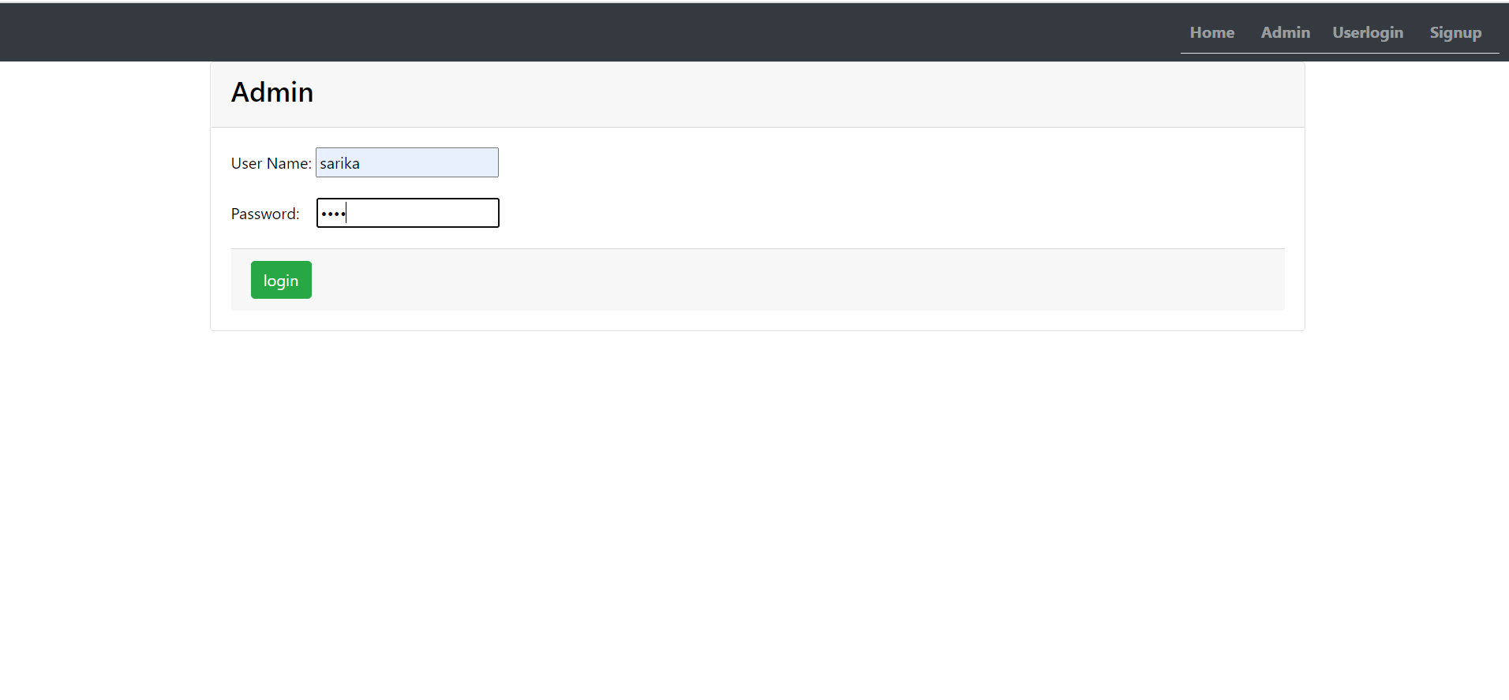

TO ADD ADMIN AND View Student Queries

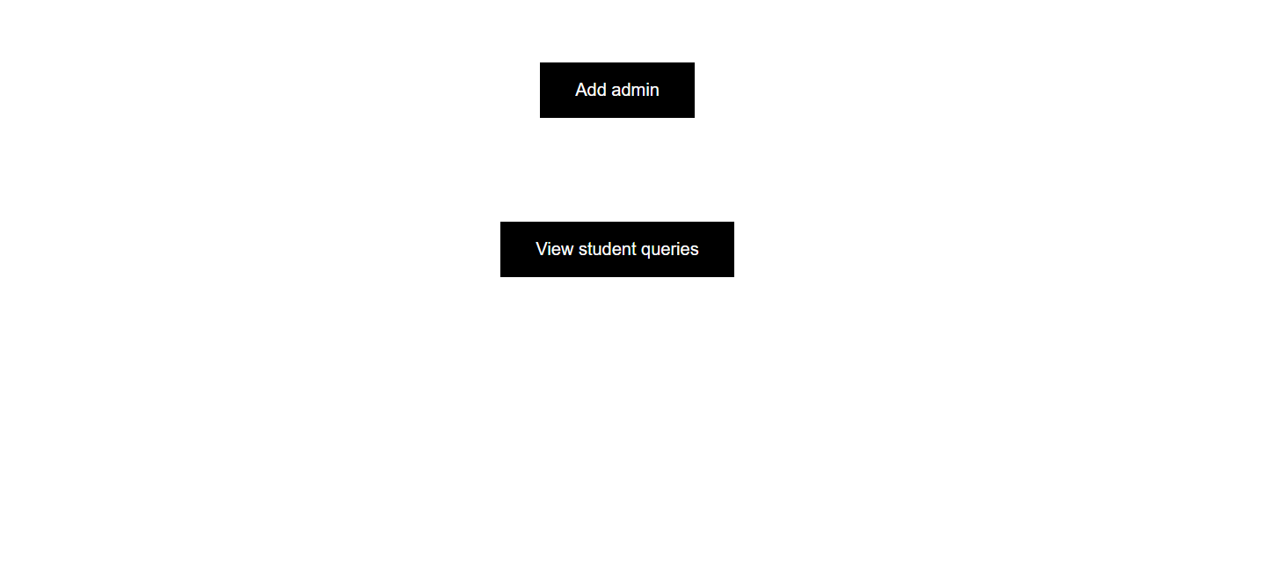

ADD ADMIN

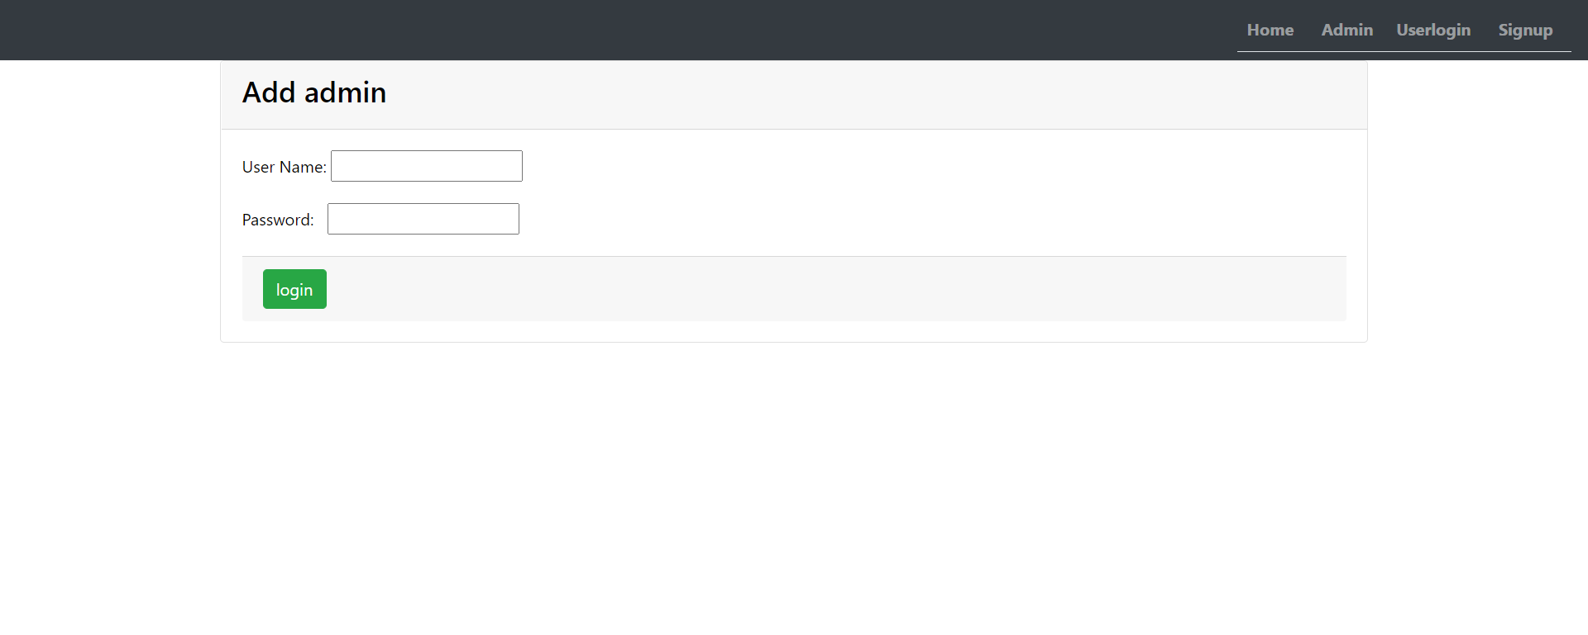

VIEW STUDENT QUERIES

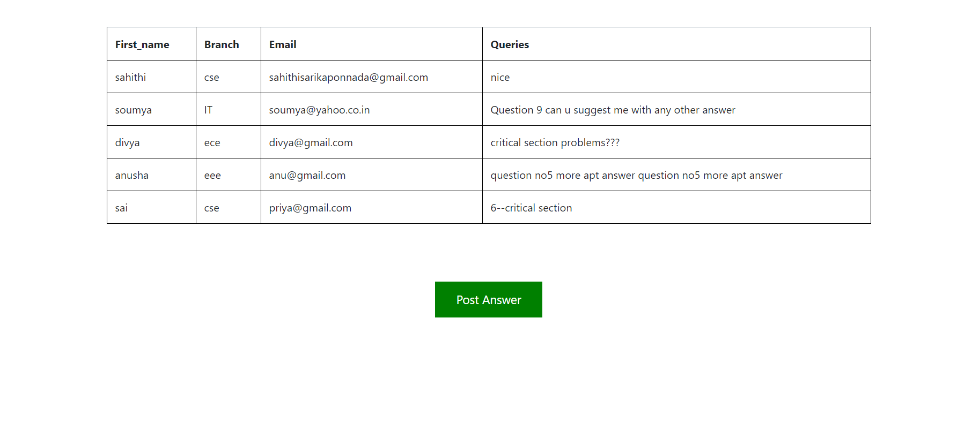

POST ANSWER

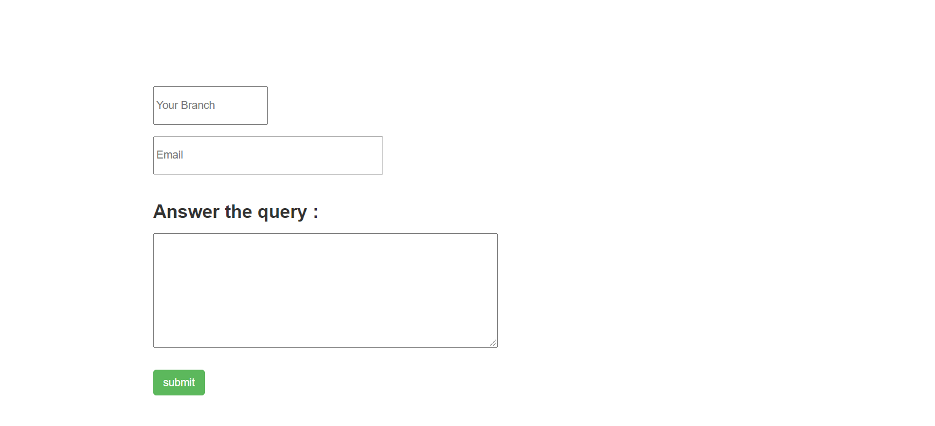

USER LOGIN

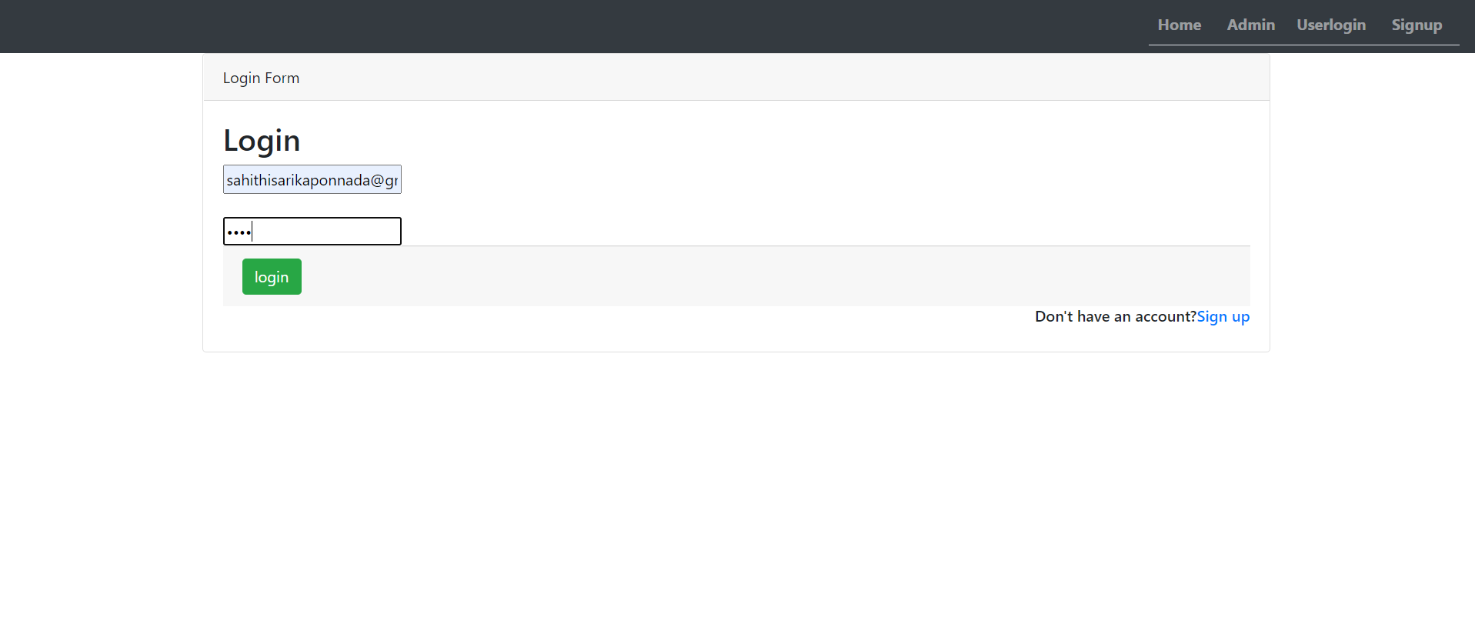

SIGNUP

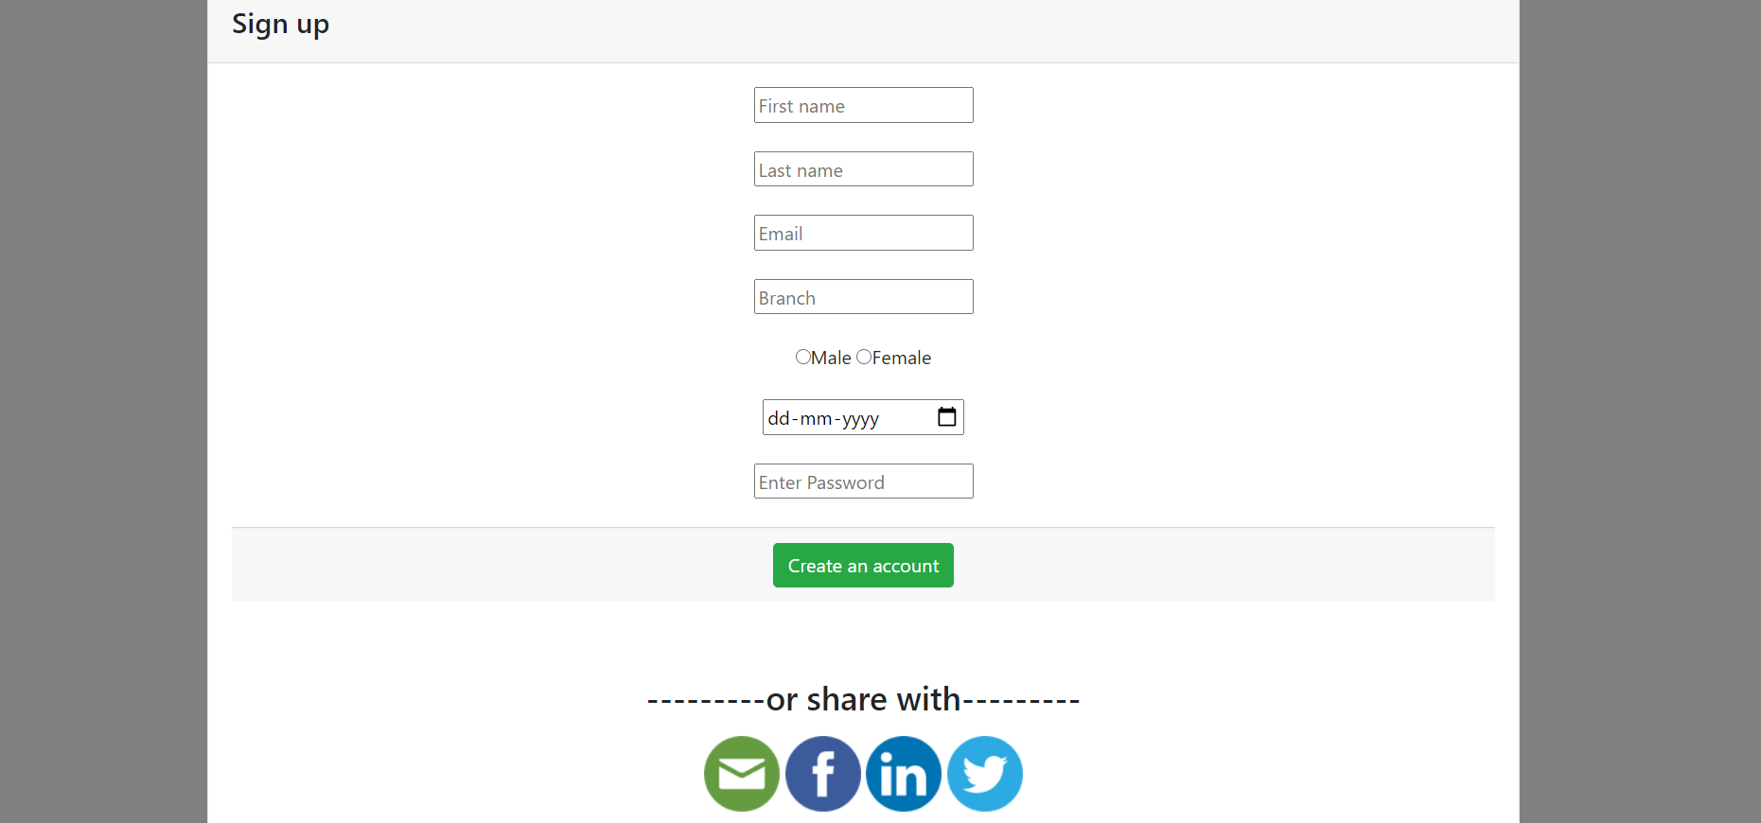

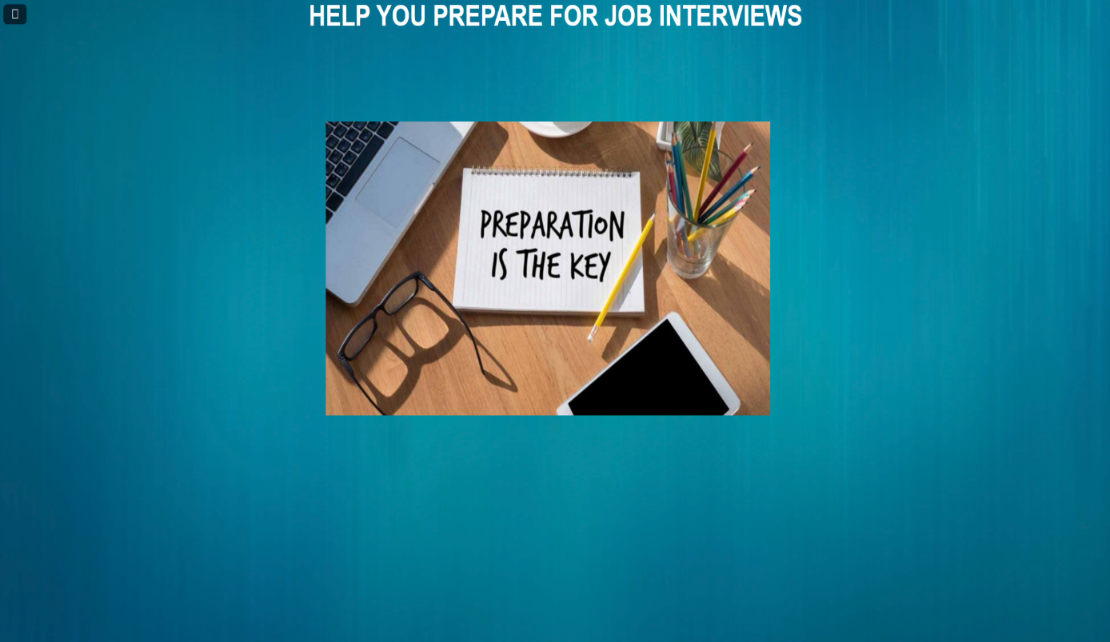 

ABOUT

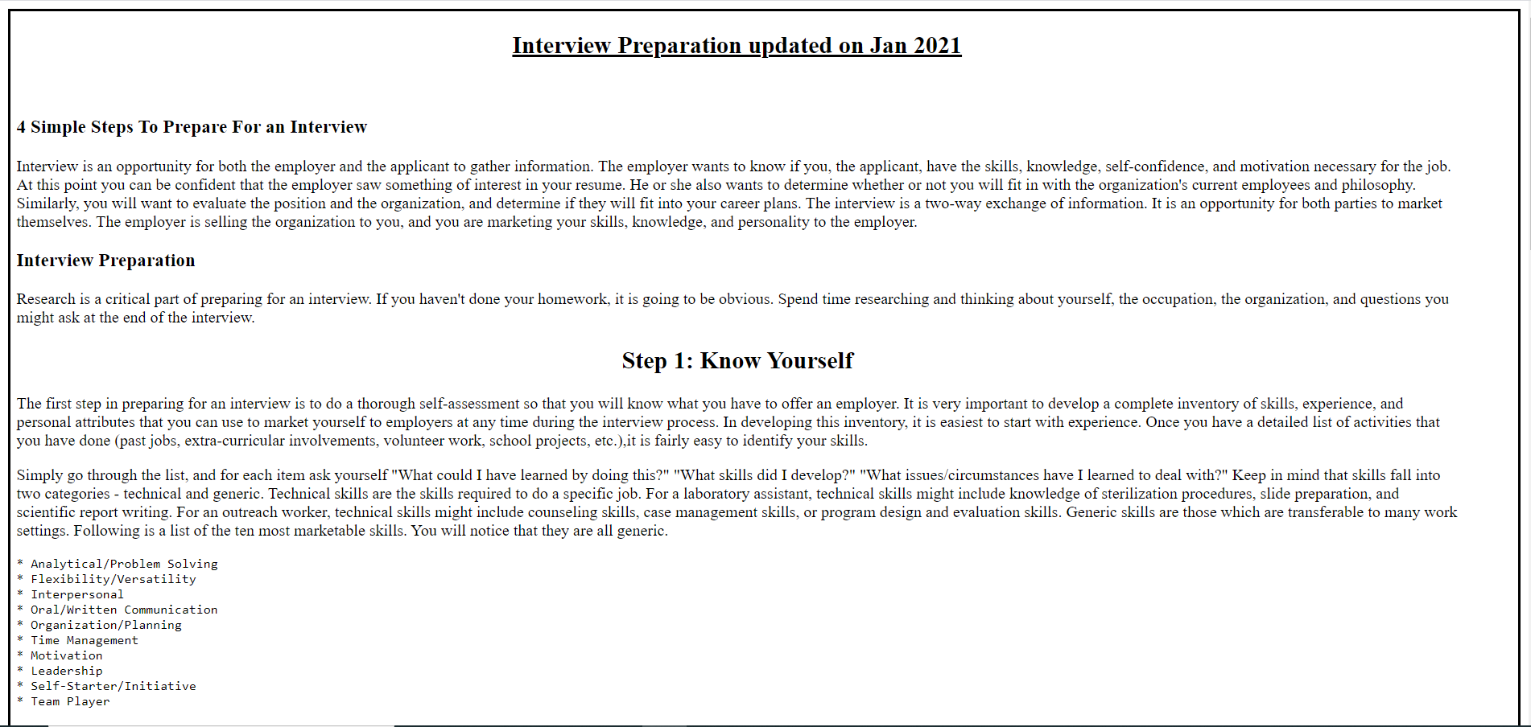

**CSE/IT**

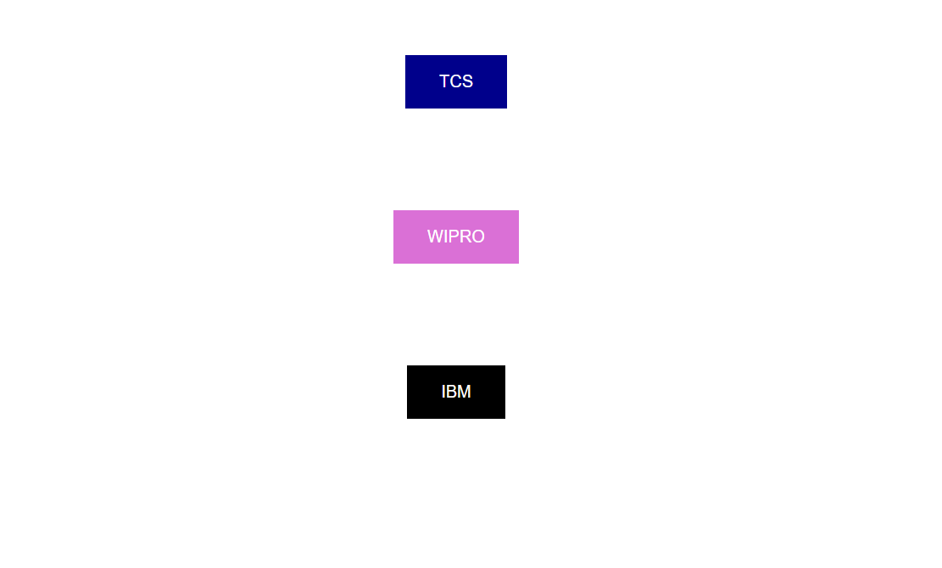  
TCS

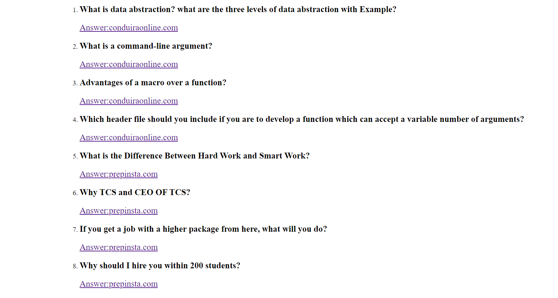

WIPRO

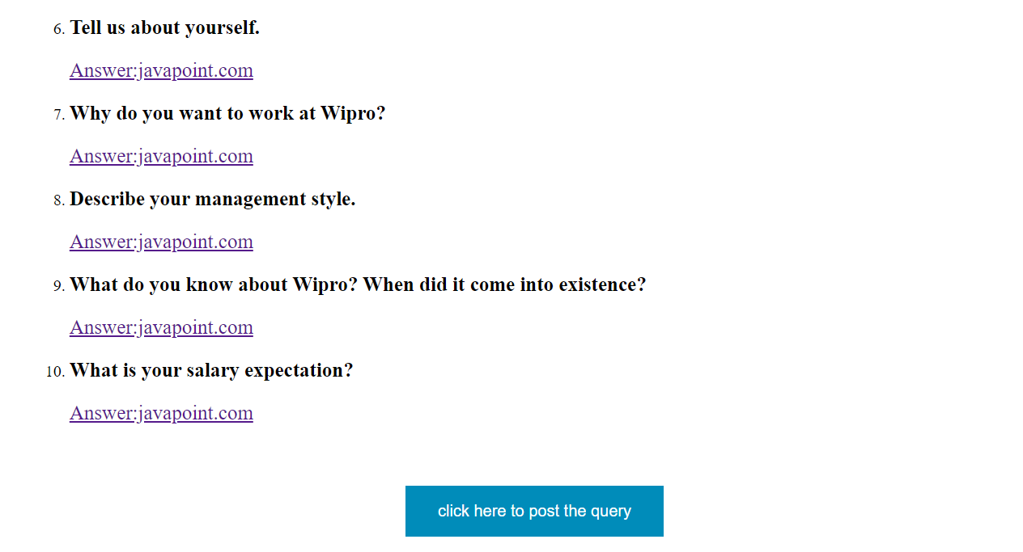

IBM

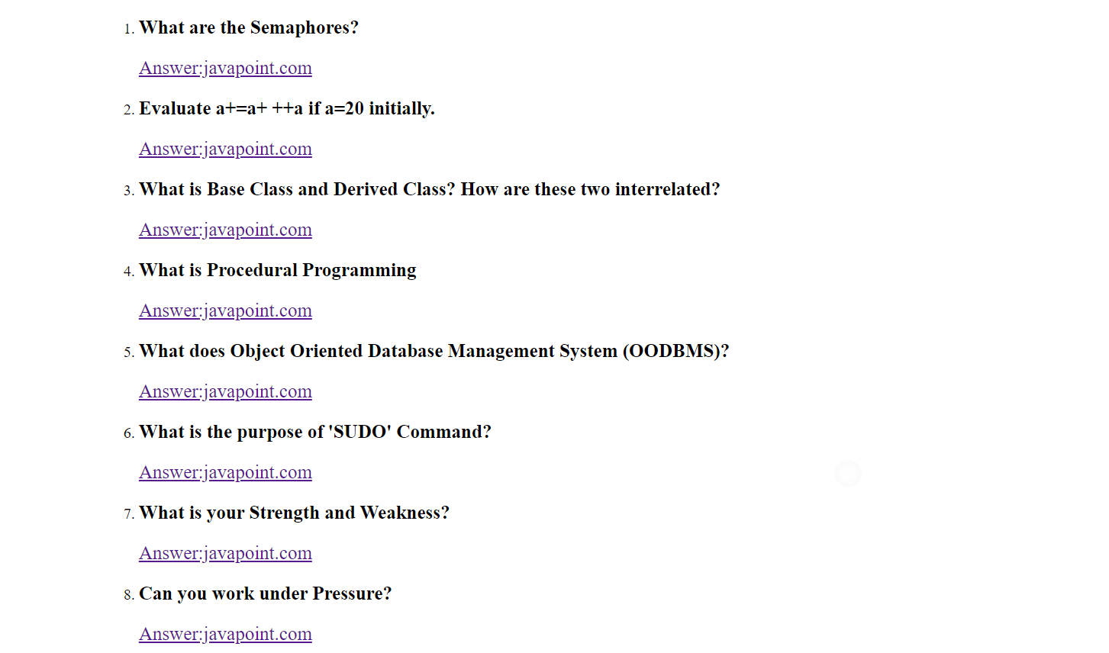

**ECE**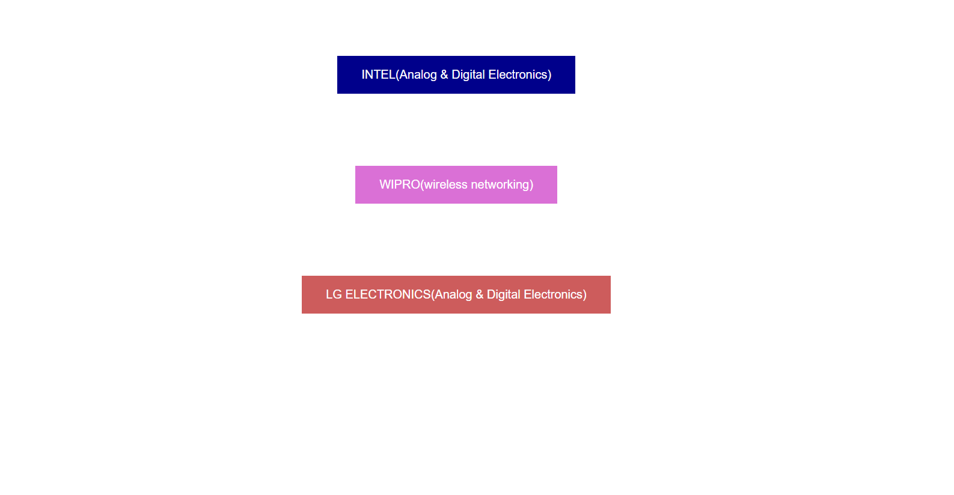

INTEL (Analog and Digital Electronics)

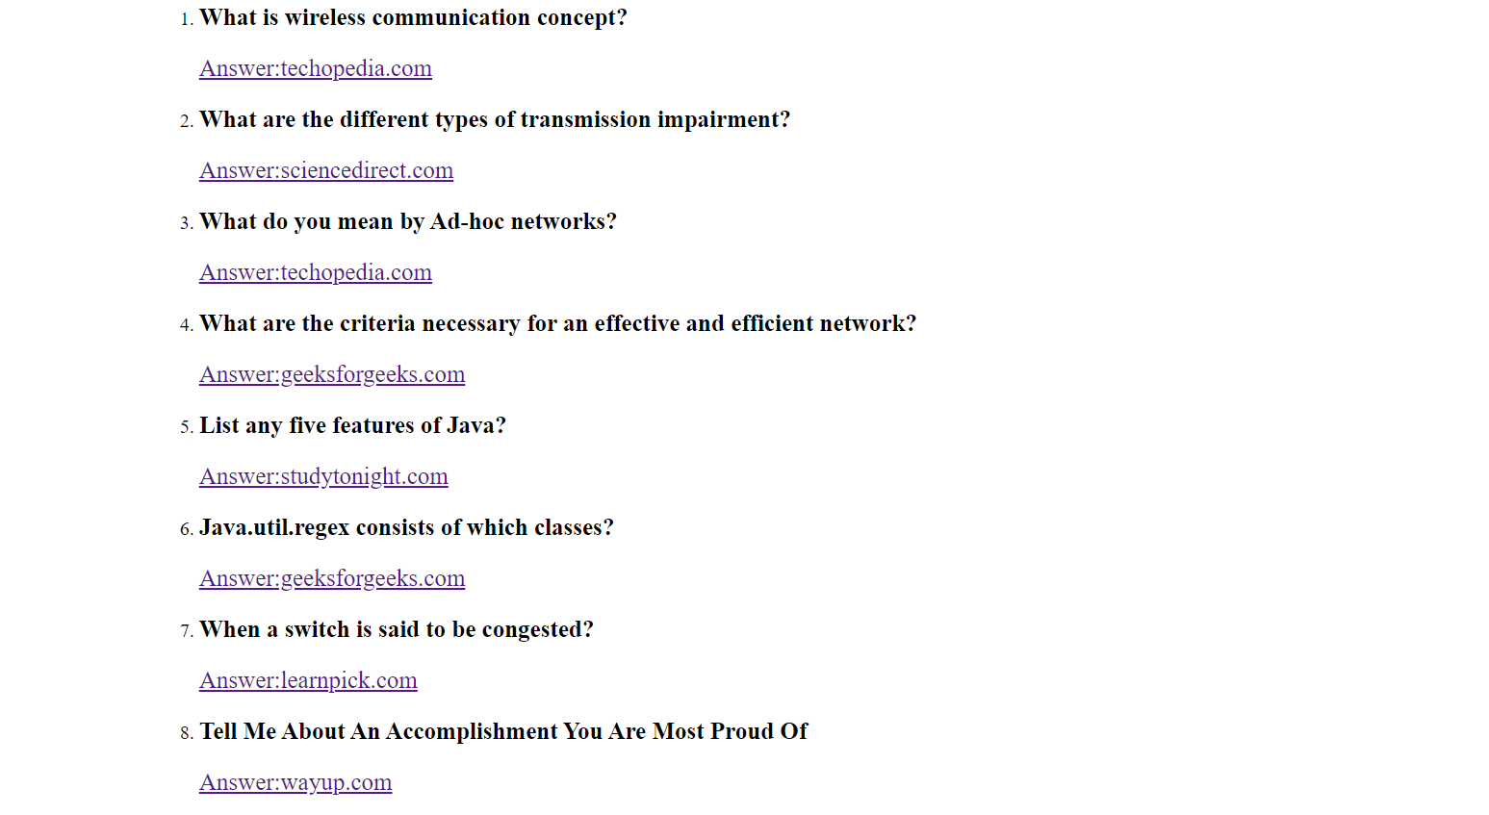

WIPRO (Wireless Networking)

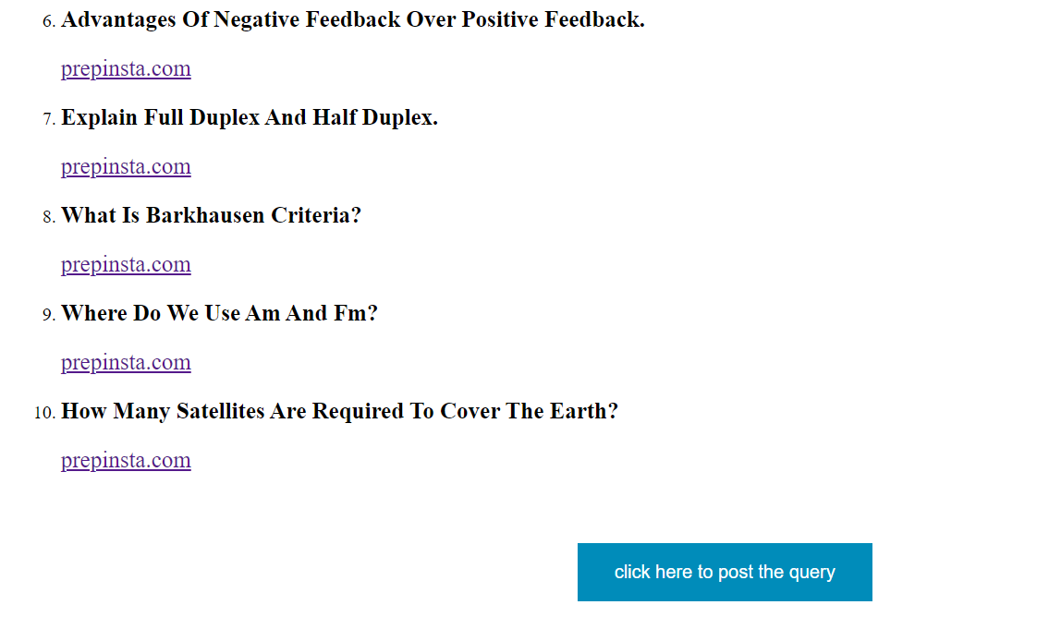

LG ELECTRONICS

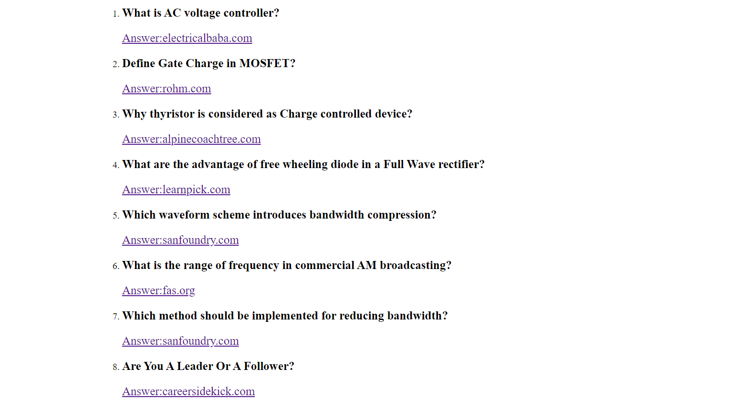

**EEE**

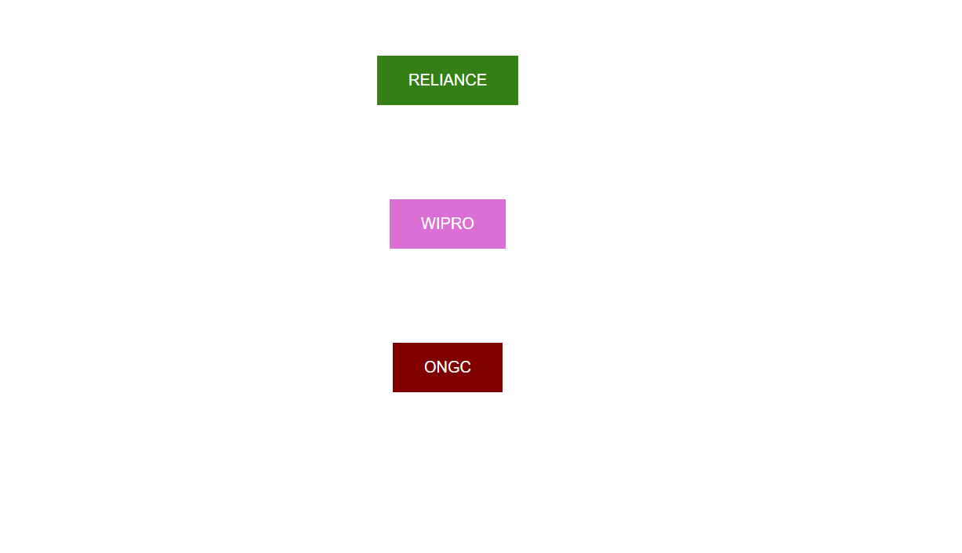

RELIANCE

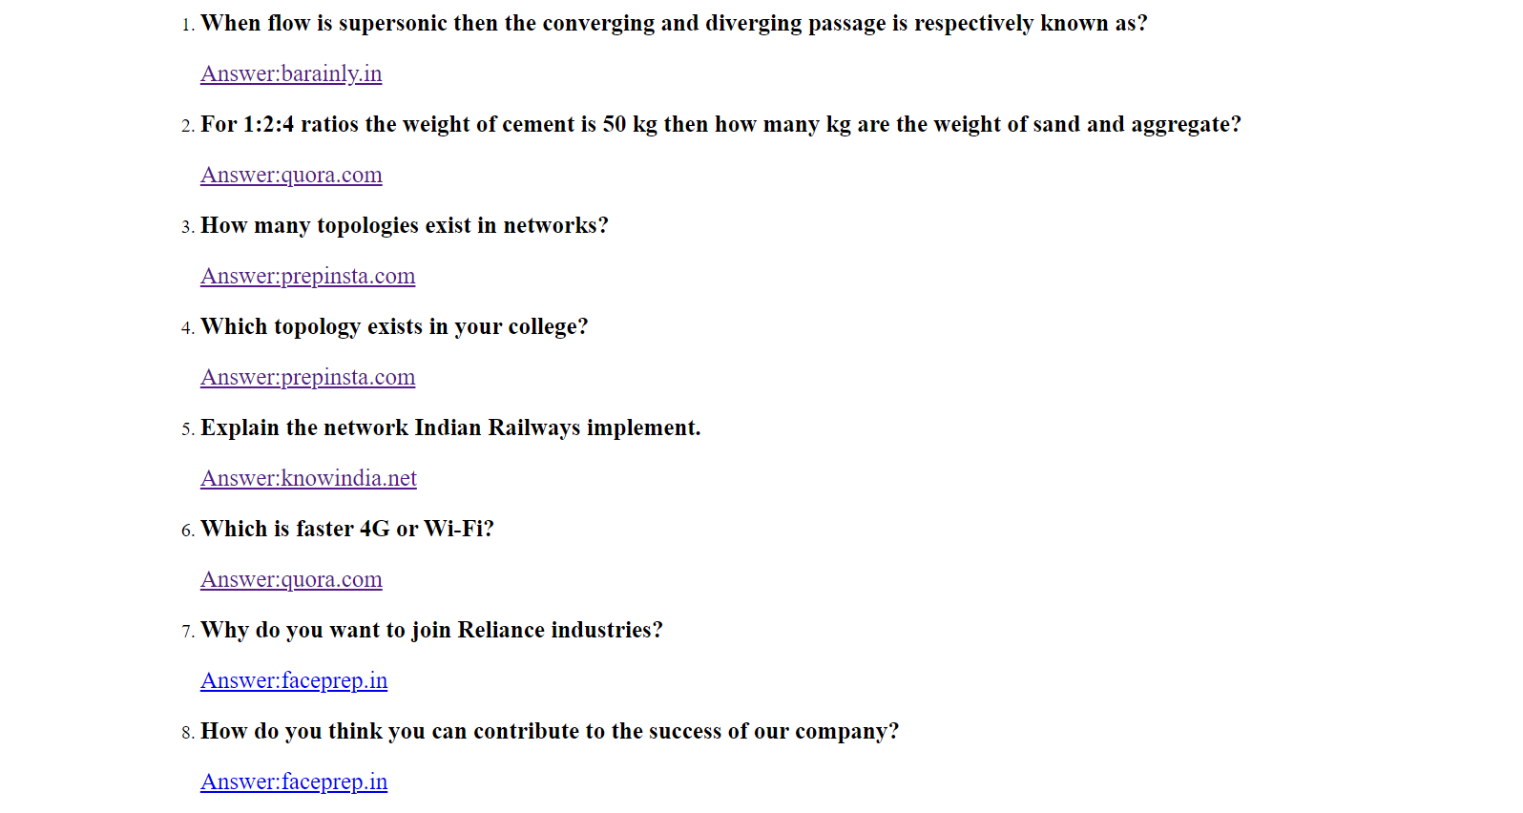

WIPRO

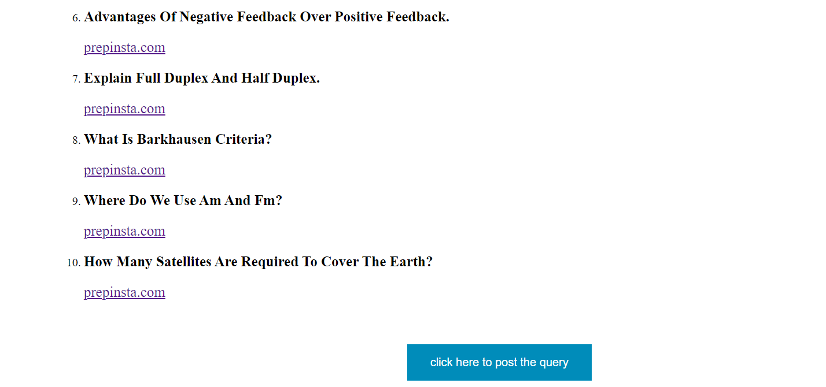

ONGC

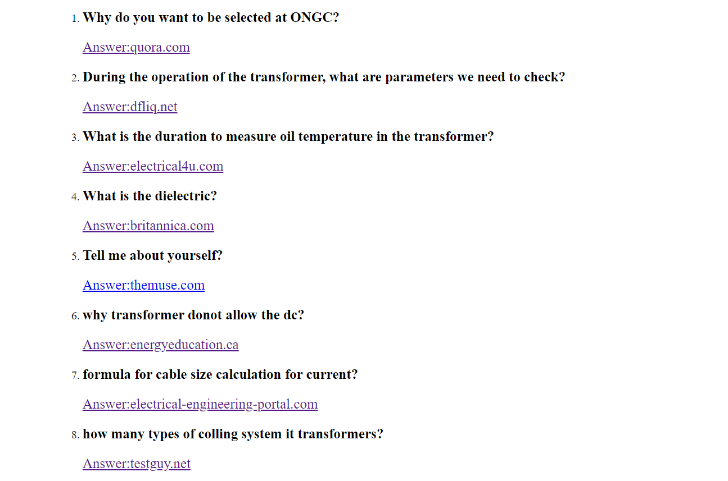

QUERIES

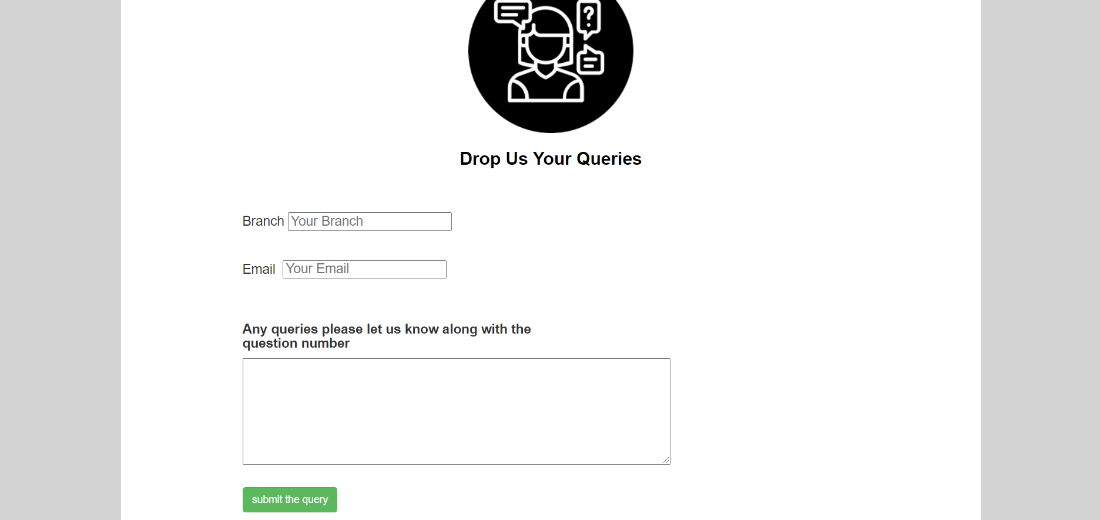

EMAIL

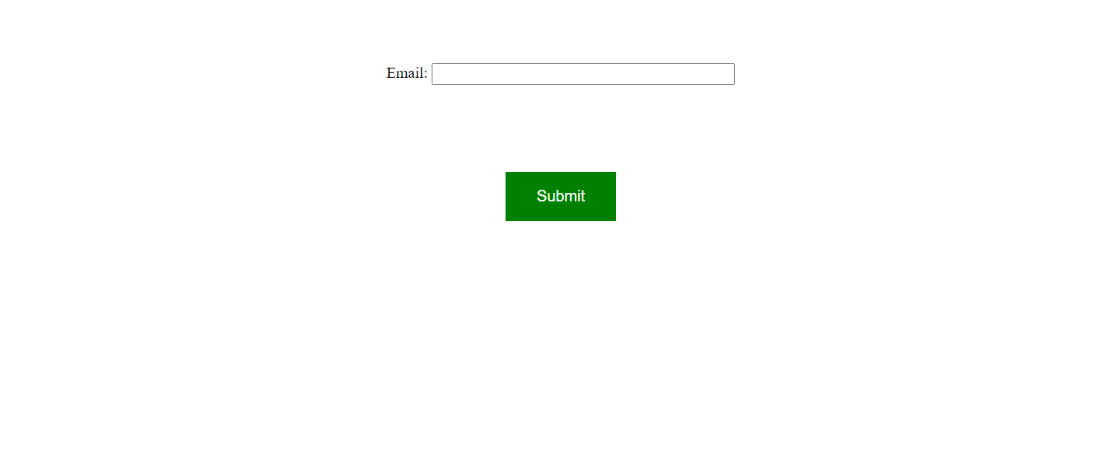

ANSWER



**REFERENCES:**

<https://youtu.be/V0O4pY2xX10>

<https://youtu.be/yaTLj4BB0T4>

<https://youtu.be/zY7q-37xYg8>

<https://youtu.be/uyaV_EWWRmo>

<https://youtu.be/1EpubtYsVzI>

<https://www.w3schools.com/bootstrap/boostrap_vcr.asp>

<https://www.w3schools.com/css/default.asp>

<https://www.w3schools.com/html/default.asp>

<https://www.w3schools.com/js/default.asp>

<https://www.google.com/search?q=gayatri+vidya+parishad+logo>

**CONCLUSION:**

Interview preparation portal is very helpful and needy to the students for last minute preparation. It saves searching time and reduces effort.

“A JOB INTERVIEW IS NOT A TEST OF YOUR KNOWLEDGE , BUT YOUR ABILITY TO USE IT AT THE RIGHT TIME.”